IIC Regional Meet at Pillai HOC College of Engineering and Technology, Rasayani on 06th February 2024

Objectives:
- To facilitate networking and collaboration among IIC institutions and ecosystem enablers to strengthen innovation ecosystems and promote inter-institutional partnerships in higher education.
- To showcase institutional achievements and innovations, provide mentoring and funding support to startups, and offer diverse learning opportunities through interactive sessions and exhibitions at one-day-long regional meets.
- To recognize and celebrate the best-performing IIC institutions and innovation ambassadors while fostering knowledge sharing and experience exchange among participants to advance the innovation movement in higher education institutions.
Benefits:
- PTVAIM’s IIC members got an opportunity to network among IIC institutions and ecosystem enablers.
- PTVAIM’s IIC members got an opportunity to showcase their growth till now to other college IIC’s.
- PTVAIM’s IIC received 3rd best IIC poster award, presented by Mr. Dipan Sahu, Assistant Director of the Ministry of Education’s Innovation Council.

Description: On 6th February 2024, Three members team COEI and IIC council current & prospective members, Smt. Anjali Paulastye – NIRF Coordinator, Mr. Mayur Khanvilkar - IIC convener, Mr. Mandar Salaskar – IIC council member attended the meet at Pillai HOC College of Engineering and Technology, Rasayani. The event hosted over 550 faculty representatives from more than 250 institutions across Mumbai.

Report on IIC Regional Meet at Pillai HOC College of Engineering and Technology, Rasayani on 06th February 2024
Three members team COEI and IIC council current & prospective members, Smt. Anjali Paulastye – NIRF Coordinator, Mr. Mayur Khanvilkar - IIC convener, Mr. Mandar Salaskar – IIC council member attended the meet at Pillai HOC College of Engineering and Technology, Rasayani. The event hosted over 550 faculty representatives from more than 250 institutions across Mumbai.
The day commenced with a tour of YUKTI Innovations/Startup stalls and Udyami Bazaar (Entrepreneurs Market), where the COEI team engaged with participants. Subsequently, IIC posters were exhibited, alongside PTVAIM's standee showcasing its key activities, followed by a presentation by Mr. Mayur Khanvilkar to evaluators. The day culminated in the inauguration of the IIC Regional Meet 2024 in the auditorium, featuring various sessions such as INDOVATION – Round Table Discussion, a Regional IIC Consortium Meeting, and discussions with Angel Investors, Incubators & Resource Agencies.
PTVAIM’s IIC members engaged in networking with other council members and were honored with the 3rd best IIC poster award, presented by Mr. Dipan Sahu, Assistant Director of the Ministry of Education’s Innovation Council. The meeting adjourned at 5:30 PM, and the team returned home on the same day, cherishing the event's memories.

Detailed Schedule of IIC Regional Meet 2024.
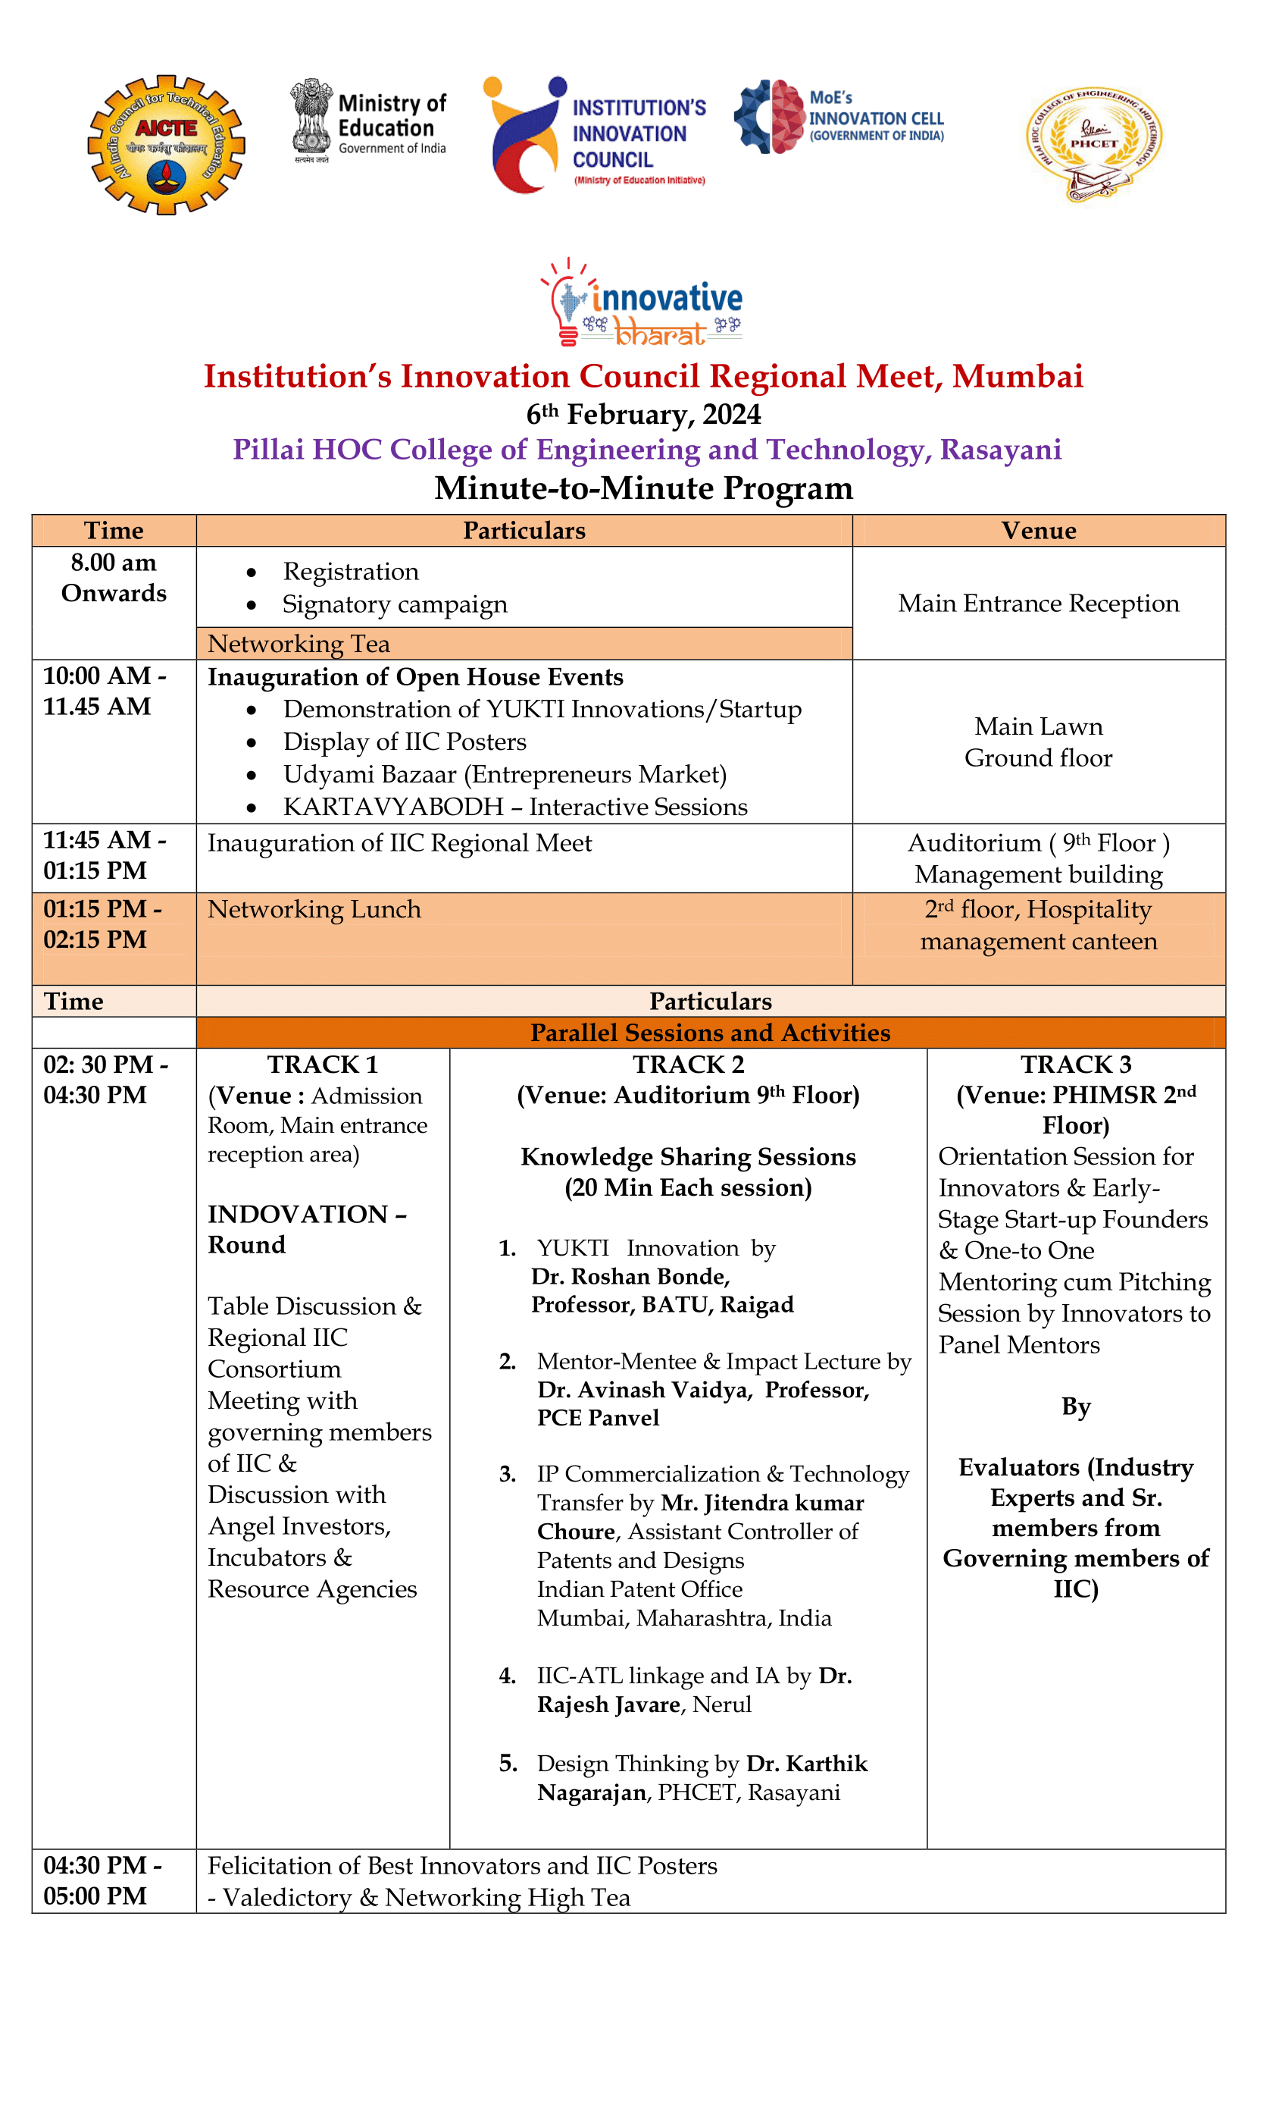

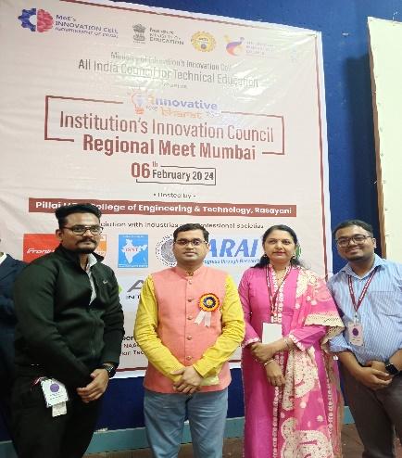
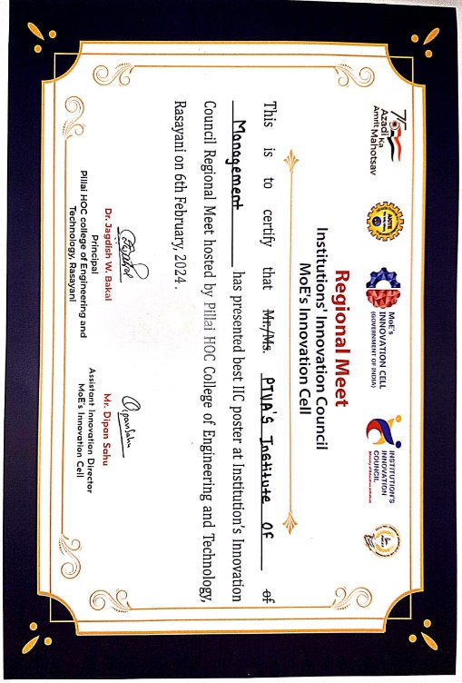
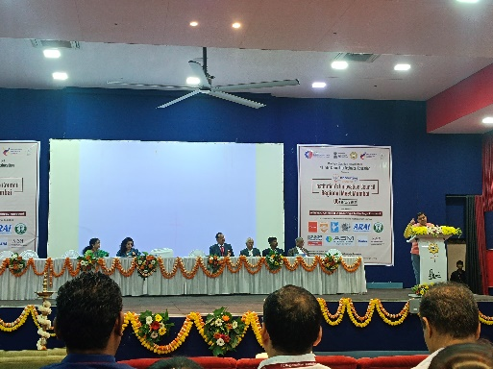
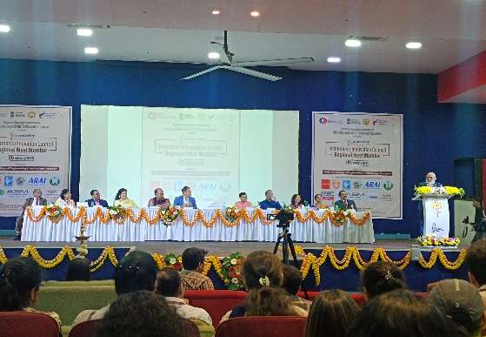
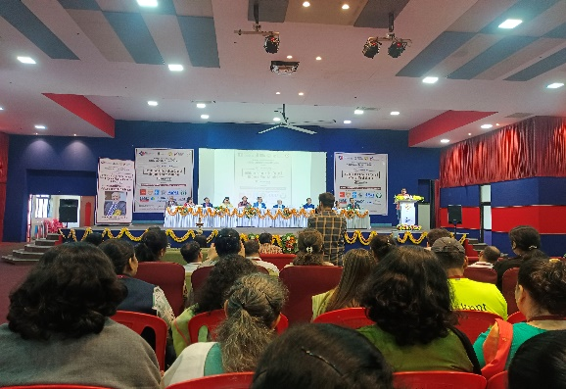
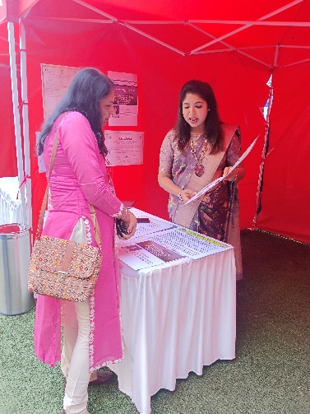
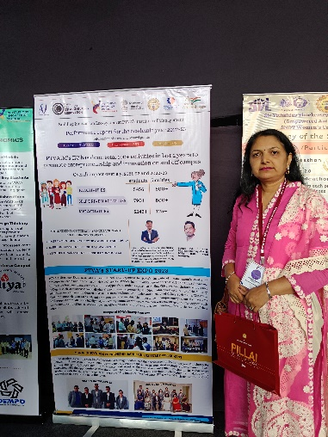
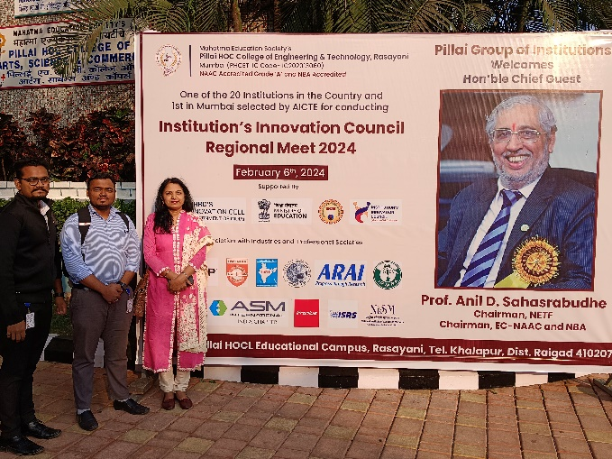
Glimpses of IIC Regional Meet 2 024.

